Into the Wilderness: Lenten Devotionals
Week 1: February 18–February 21

The LORD went in front of them in a pillar of cloud by day, to lead them along the way, and in a pillar of fire by night, to give them light, so that they might travel by day and by night. Neither the pillar of cloud by day nor the pillar of fire by night left its place in front of the people.
—Exodus 13:21–22
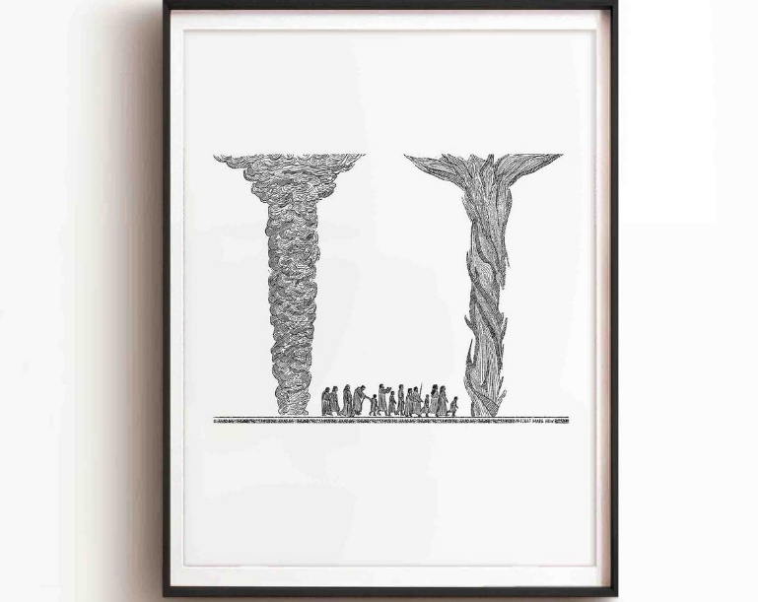

This Week’s Schedule
Tuesday, February 17: Shrove Tuesday Pancake Supper, 5 P.M.
Wednesday, February 18: Ash Wednesday
- Ashes to go: 8 to 11 A.M. in sanctuary
- Worship service at Galloway Ridge, noon
- Worship service at Chapel in the Pines, 6:30 P.M.
February 18, 2026 – Ash Wednesday
We begin with the Israelites' first journeys into the wilderness. After the tenth and final plague, Pharaoh finally told Moses and Aaron to lead the people out of Egypt (Exodus 12:31). However, the Israelites did not go the shortest route because it might have led to conflict with the Philistines (Exodus 13:17). They were led through the desert on a new route, not down one of the established roads. Sometimes, God works like that.
The people began by walking 120 miles or so from Rameses to Succoth (Exodus 12:37) and then another 150 miles from Succoth to Etham (Exodus 13:20). That’s a long way to journey, but the Lord led them by day and night (Exodus 13:22). God works like that, too.
Guide me feet, while I run this race,
for I don’t want to run this race in vain!
- “Guide My Feet,” African American Spiritual

February 19, 2026
As we saw yesterday, the Israelites traveled long distances through the desert down an uncharted path. However, I wonder if some of the most difficult steps were the first ones. Sometimes, life is like that.
The Israelite people had lived in Egypt for 430 years (Exodus 12:41). Our country is much younger. Even in a single lifetime, it is too easy to become entrenched in our routines and resist change, even when prompted. But trusting that the Lord goes ahead of us, we can begin. We might surprise everyone, including ourselves, by how far we go.
Faith is taking the first step even when you don’t see the whole staircase.
- Martin Luther King Jr.

February 20, 2026
The Hebrew word for “pillar” (amud) is derived from the root that means “standing.” As such, a pillar most often refers to a beam or column that supports a building or home. By definition, such pillars are stationary.
Yet, the Lord was in the pillars of cloud and fire that went ahead of the Israelites. Figuratively, these pillars might be thought of as providing divine guidance as well as support. Our journeys, whether physical or spiritual, can be perilous. It’s comforting to trust that we can rely on God’s steadfastness.
This life after all is a miracle and we ought to pay fierce attention every moment, as much as possible.

- Brian Doyle

February 21, 2026
I want to close the first week of our Lenten journey “into the wilderness” by noting that, while the Israelites were led by the Lord, they also walked together in community. God provided them with physical guidance and spiritual support, represented by the pillars of cloud and fire, but they also had each other. Let’s give thanks for the gift of community.
The other day, I was having coffee in the Belted Goat when I read the following on the back of a hooded sweatshirt of one of my fellow patrons:
Dear person behind me,
The world is a better place with you in it.
Love,
the person in front of you

